**Homework 3**

1. **Academic integrity**

I have read and understood the course academic integrity policy.

1. **TCP sequence numbers** – Host A and Host B are communicating over a TCP connection channel, and Host B has already received from host A all bytes up through byte 139. Suppose that A sends two segments to B back-to-back. The first and the second segments contain 30 and 50 bytes of data, respectively. In the first segment, the sequence number is 140, source port number is 543, and the destination port number is 80. Host B sends an ACK whenever it receives a segment from Host A.
2. In the second segment sent from A to B, what are the sequence number, source port number, and destination port number?

The sequence number is 170, the source port number is 543 and the destination port number is 80.

1. If the first segment arrives before the second segment, in the ACK of the first arriving segment, what is the ACK number, the source port number, and the destination port number?

The ACK number is 170, the source port number is 80 and the destination port number is 543.

1. If the second segment arrives before the first segment, in the ACK of the first arriving segment, what is the ACK number?

The ACK number is 140.

1. Suppose the two segments sent by A arrive in order at B. The first ACK is lost and the second ACK arrives after the first timeout interval, as shown in the figure below. Complete the diagram, showing all other segments and ACKs sent. Assume there is no additional packet loss. For each segment you add to the diagram, provide the sequence number and number of bytes of data; for each ACK that you add, provide the ACK number.

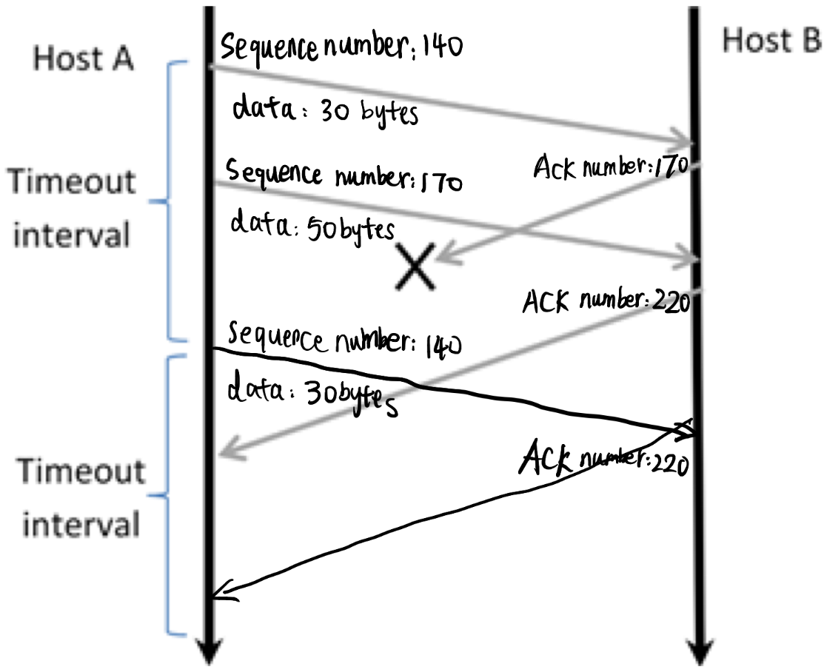

1. **Compare GBN, SR, TCP (no delayed ACK, no SACK)** – Assume that the timeout values for all three protocols are sufficiently long such that 5 consecutive data segments (each containing only one byte) and their corresponding ACKs can be received (if not lost in the channel) by the receiving host (Host B) and the sending host (Host A), respectively. Suppose Host A sends 5 data segments to Host B, and the 2nd segment (sent from A) is lost – this is the only data segment or ACK loss. In the end, all 5 data segments have been correctly received by Host B. How many segments has Host A sent in total and how many ACKs has host B sent in total? What are data segment and ACK sequence numbers? Answer these two questions for all three protocols.

GBN:

Host A sent 9 segments, which are (1 2 3 4 5) → (2 3 4 5) respectively, and Host B sent 8 ACKs, which are (1 1 1 1) → (2 3 4 5) respectively.

SR:

Host A sent 6 segments, which are (1 2 3 4 5) → (2) respectively, and Host B sent 5 ACKs, which are (1 3 4 5) → (2) respectively.

TCP:

Host A sent 6 segments, which are (1 2 3 4 5) → (2) respectively, and Host B sent 5 ACKs, which are (2 2 2 2) → (6) respectively.

1. **TCP congestion control** – Consider sending a large file from one host to another over a TCP connection that has no loss. p44
2. Suppose TCP uses AIMD for its congestion control without slow start. Assuming cwnd increases by 1 MSS every time a batch of ACKs is received, and assuming constant round-trip times, how long does it take for cwnd to increase from 1 MSS to 6 MSS?

It takes 1 + 2 + 3 + 4 + 5 + 6 = 21 RTT for cwnd to increase from 1 MSS to 6 MSS.

1. What is the average throughput (in terms of MSS and RTT) for this connection up through time = 5RTT?

The whole data = 1 + 2 + 3 + 4 + 5 = 15 MSS , and the average throughput = 15 ÷ 5 = 3 MSS/RTT.

1. **TCP throughput** – Consider that a single TCP (Reno) connection uses one 15 Mbps link which does not buffer any data. Suppose that this link is the only congested link between the sending and the receiving hosts. Assume that the TCP sender has a huge file to send to the receiver, and the receiver’s receive buffer is much larger than the congestion window. We also make the following assumptions: each TCP segment size is 1,500 bytes; the two-way propagation delay of this connection is 150 msec; and this TCP connection is always in congestion avoidance phase, that is, ignore slow start.
2. What is the maximum window size (in segments) that this TCP connection can achieve?

The maximum window size = 15 Mbps ÷ (MSS ÷ RTT) = 15000000 ÷(1500 × 8 ÷ 0.15) = 188 segments.

1. What is the average window size (in segments) and average throughput (in bps) of this TCP connection?

The average window size = 141 segments and average throughput = average window size × (1500 × 8 ÷ 0.15) = 11280000 bps = 10.76 Mbps.

1. How long would it take for this TCP connection to reach its maximum window again after recovering from a packet loss?

It takes (188 ÷ 2) × 0.15 = 14.1s to reach its maximum window again after recovering from a packet loss.

1. Repeat (a), (b), (c) but replacing this 15 Mbps link with a 15 Gbps link. Do you see a problem for the TCP connection in this scenario? Suggest a simple solution to this problem.

The maximum window size = 15 Gbps ÷ (MSS ÷ RTT) = 15000000000 ÷ (1500 × 8 ÷ 0.15) = 187500 segments.

The average window size = 140625 segments and average throughput = average window size × (1500 × 8 ÷ 0.15) = 11250000000 bps = 1.34 Gbps.

It takes (187500 ÷ 2) × 0.15 = 14062.5s to reach its maximum window again after recovering from a packet loss.

So in this case, the time taken for a TCP connection to reach its maximum window again after recovering from packet loss is too long. We can increase MSS.